## <https://medium.com/@gmecon7/how-did-healthy-become-trendy-60e2a24f6e3>

## How Healthy Became Trendy

Bulletproof coffee. Turmeric powder. Acai bowls. Soul Cycle. Kombucha. If you’re on any form of social media, you have probably heard of at least one of these health fads. Every week, it seems, millennial media influencers in New York and Los Angeles proclaim some miracle food, powder or exercise class that is miraculous. They all claim something either different from its counterparts, or it offers the same exact thing. How do we know what health trends are legitimate and which ones are total scams? How did being healthy become a trendy lifestyle that people seek? 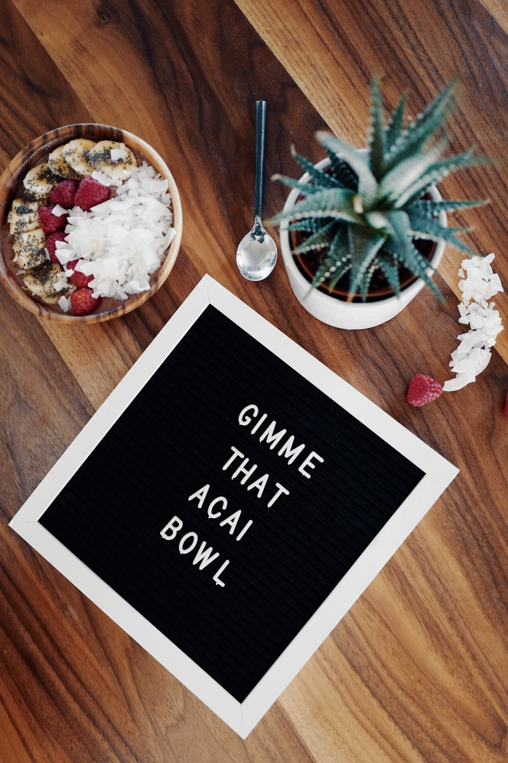

I can’t lie to you and say that I haven’t tried every single one of the items I listed above. Sometimes I ask myself, is this really doing anything for me, or am I just doing it because it comes in fancy packaging and its sold at Whole Foods?

According to [Forbes](https://www.forbes.com/sites/deborahweinswig/2017/06/30/wellness-is-the-new-luxury-is-healthy-and-happy-the-future-of-retail/#3187bbc78323), millennials like myself are the driving factor behind this new era. We wear our workout clothes out and about daily, also known as ‘athleisure,’ and we are more willing to invest our money and time into our health and fitness. The Atlantic, a news outlet based out of Boston, has a miniseries titled “If Our Bodies Could Talk,” where host Dr. James Hamblin tries these health fads for himself (check out the video I’ve linked below to see one of personal favorites about Kombucha).

Everything now is about ‘aesthetics.’ It’s about looking cool. Do you have trendy pictures of your beautifully plated avocado toast on your Instagram feed as your #postworkout meal? The likes pour in on these types of posts from fellow millennials who all go to that one place in town that makes the most ‘Instagram-worthy’ food. Just like with any fad, whether it’s a crash diet or some fashion item, people just want to be a part of the club, in my opinion, and be able to say, “Oh yeah, I do that too.”

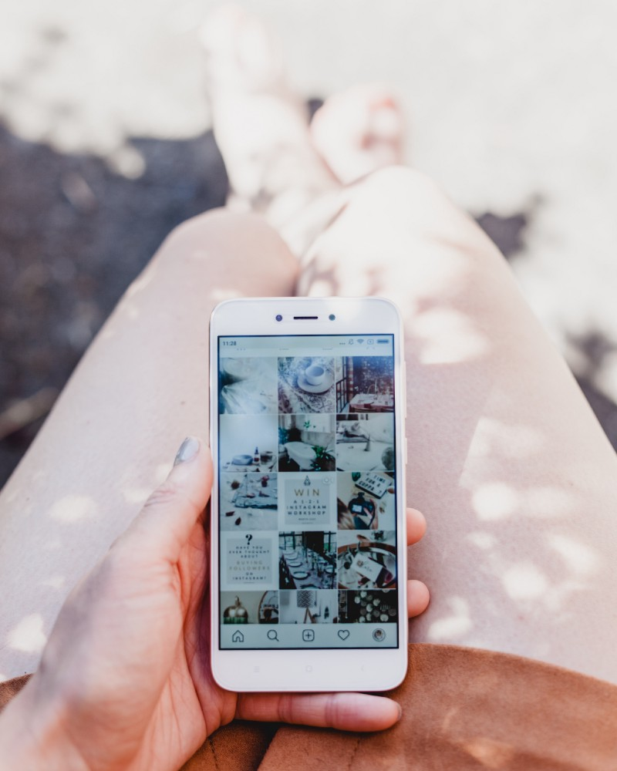

Instagram Feed by Georgia de Lotz

Another article from [Forbes](https://www.forbes.com/sites/jefffromm/2017/11/15/millennial-views-of-health-are-holistic-yet-inconsistent-how-can-brands-help/#4a7acba01eff) cites a statistic from Iconoculture Consumer Insights, which says that 71% of millenials believe that mental and physical health go hand in hand. But this new age of green juices and hot yoga can lead to a dangerous and obsessive lifestyle that can actually do more harm than good. If there is a societal pressure to uphold a certain ‘healthy’ lifestyle, where does that leave our mental health? This is where issues such as body image come into play.

If you ask any girl in college, they most likely will say that social media influences the way they feel about themselves, especially when it comes to the type of people they follow. We feel like we need to look a certain way or live a certain lifestyle in order to emulate this ‘happiness’ they seem to have. My personal mantra is to simply work hard. Of course, sometimes I envy these fancy lifestyles these influencers flaunt, but I always tell myself if I work hard enough, I can have the same things one day.

Living a healthy lifestyle should be something you do for you, not somebody else. Otherwise, you're doing it for all the wrong reasons. You should want to be fit because you feel great, not because you feel like you have to be. As someone who loves to fall in to the trend traps, I still am confident enough in myself to make my own decisions when it comes to my health. Take control of your health and don't let social media control you.